Report Advanced Refresh Scenarios

by Aliaksandr Labayeu

# Execution of select statements

2 Statements were built so as to get results about execution of select statements in 3nf layer and DWH layer, which brings the same amount of rows and same result:

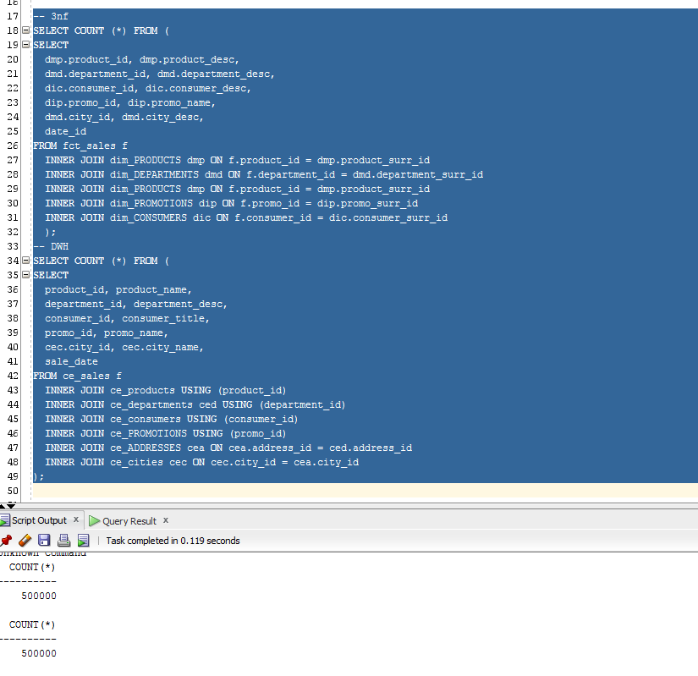

As a result DWH statement gets cost in 1219 that is 20% faster than execution from the 3nf layer that is shown below:

**DWH**

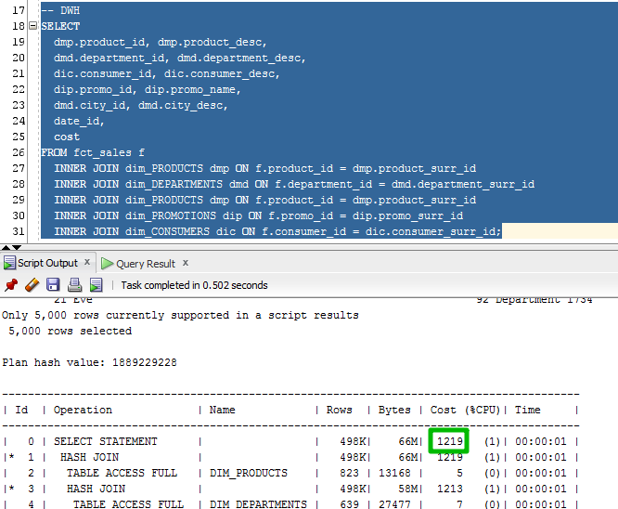

**3NF**

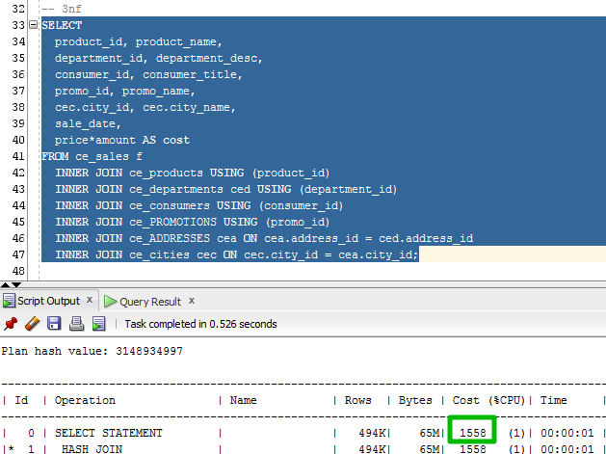

It should be mentioned that only 5000/500 000 were selected and DWH would get much better results if it was the full execution. It also should be add that if we’d like to get more drill down relations in 3nf schema, we would get much worse results when there would be no difference with the same statement in DWH, because of the presence of additional fields in dimensions.

# Additional execution

Additional execution from FACT table can show another great difference in performance between two models:

